Mini Washbrook

Wall Hung Urinal
VF-6401

FEATURE

Easy to Clean
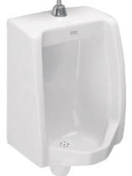
Overflow hole

SPECIFICATIONS

Flush Valve Drillings: Single
Basin Dimensions: W320xL345xH605mm.
Material : Vitreous China

COLOR AVAILABILITY

White (WT)

INCLUDED COMPONENTS

Wall fixing set for Lavatory
Installation manual
Outlet rubber connector
Hanger for Urinal

DIMENSIONAL DRAWING
SHIPPING WEIGHT
Net Weight: 19 KG
Gross Weight: 22 KG
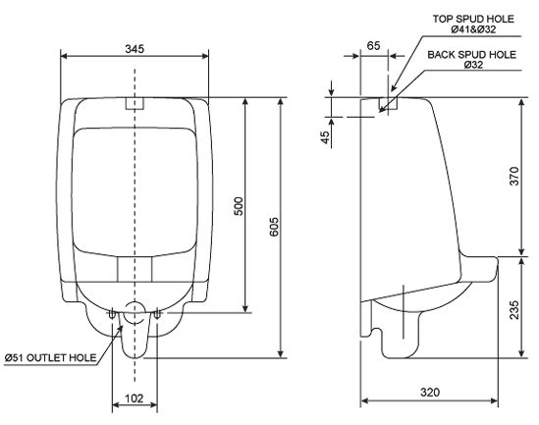

STANDARDS CRITERIA
TIS Standard
EN Standard
ASME Standards

This document is the property of American Standard. It can neither be reproduced, nor communicated, without authorization.
American Standard reserves the right to change dimensions and specifications without notice, we assume no liability for the use of obsolete dimensions.

