

Basin Mono Faucet

Basin Mono Faucet
FFAS1M06-101500BF0
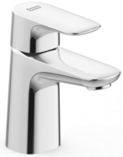

Flow Chart Diagram
Water Pressure | 0.5 Bar | 1 Bar | 2 Bar | 3 Bar | 4 Bar | 5 Bar
Flow Rate （L/Min ） | 2.4 | 3.6 | 5.1 | 5.28 | 5.46 | 5.64

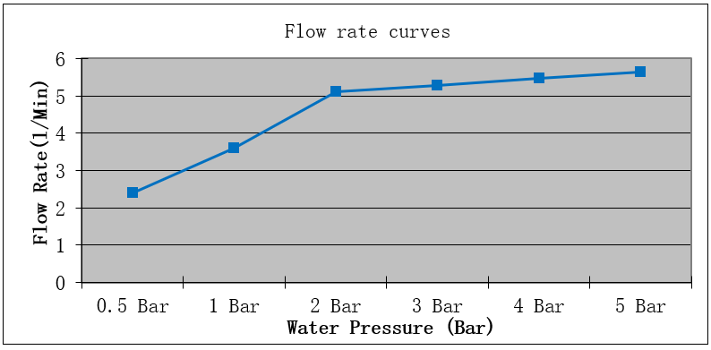

This document is the property of American Standard. It can neither be reproduced, nor communicated, without authorization.
American Standard reserves the right to change dimensions and specifications without notice, we assume no liability for the use of obsolete dimensions.
Rev.: D/0

